CSA1708-ARTIFICIAL INTELLIGENCE
LAB EXPERIMENTS

Program 3: Python Program for the Water Jug Problem

Aim
To write a Python program that solves the Water Jug Problem using Breadth-First Search (BFS).

Algorithm
- Enter the capacities of the two jugs and the target amount.
- Start with both jugs empty.
- Use BFS to explore possible states.
- Generate new states by filling, emptying, or pouring between the jugs.
- Stop when either jug contains the target amount.
- Display the steps to reach the target.

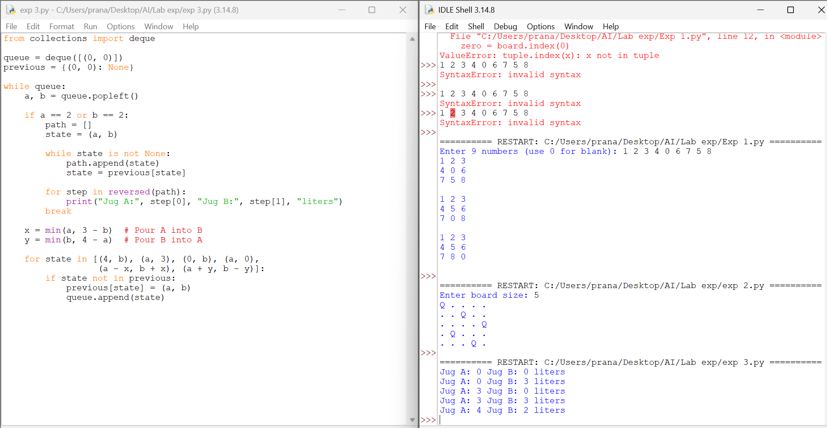

RESULT

Thus, the Water Jug Problem was solved successfully using Python and Breadth-First Search.

